**R&D Report on TCP/IP Model**

Prepared by:

Virat Pandey

Celebal Technology

Cloud Infrastructure & Security Internship

Research & Development Document

June 8, 2025

# **TABLE OF CONTENT**

1. Introduction

2. Overview of TCP/IP Architecture

3. Layer-wise Explanation

    3.1 Application Layer

    3.2 Transport Layer

    3.3 Internet Layer

    3.4 Network Access Layer

4. Comparison with OSI model

5. Real-World Relevance

7. Conclusion

8. References

# **Introduction**

The **TCP/IP Model** (Transmission Control Protocol/Internet Protocol) is the foundational framework upon which the modern internet is built. Originally developed by the U.S. Department of Defence in the 1970s to support robust and fault-tolerant communication between military networks, the model has since evolved into the global standard for digital communication.

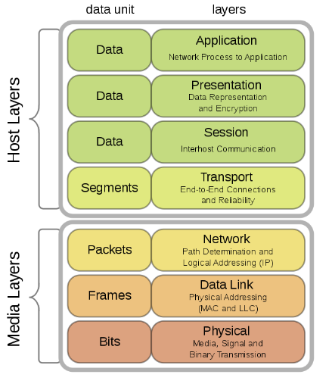Unlike the theoretical OSI model, the TCP/IP model was designed for **practical implementation**. It defines how data should be **packaged, addressed, transmitted, routed, and received** across networks — from small local systems to the vast infrastructure of the internet.

The model is composed of **four functional layers**:

1. Application
2. Transport
3. Internet
4. Network Access

Each layer is responsible for a specific set of tasks in end-to-end communication. Together, they ensure seamless data transfer between devices regardless of underlying hardware or operating systems.

This report explores the structure, function, and real-world application of the TCP/IP model, highlighting its critical role in today’s **cloud-based, security-driven** networking environments. The TCP/IP model is not only used in academic environments but also forms the backbone of **modern enterprise networks, cloud platforms.**

# **Overview of TCP/IP Model**

The **TCP/IP (Transmission Control Protocol/Internet Protocol) Model** is a practical, implementation-driven framework that outlines how data is communicated across interconnected devices and networks. Unlike the OSI Model, which is more theoretical, the TCP/IP model was developed alongside the protocols it describes making it the foundation of the **modern internet and enterprise network systems**.

The architecture consists of **four layers**, each performing a defined role in the data transmission process:

1. **Application Layer** – Interfaces with end-user software and services
2. **Transport Layer** – Ensures reliable or fast communication between devices
3. **Internet Layer** – Handles logical addressing and routing of packets
4. **Network Access Layer** – Manages data link and physical network interfaces

Each layer interacts directly with the one above and below it, maintaining a modular flow of data. According to Microsoft Learn:

*"TCP/IP uses layers to separate networking functions and allow developers to focus on one aspect of communication without affecting the rest."* — Microsoft Learn[[1]](https://learn.microsoft.com/en-us/xandr/industry-reference/tcp-ip)

While the layers differ slightly in naming and scope from the OSI model, the TCP/IP stack has become the **de facto standard** for real-world networking, from configuring firewalls and routing rules to enabling virtual machines to communicate across subnets in a cloud environment.

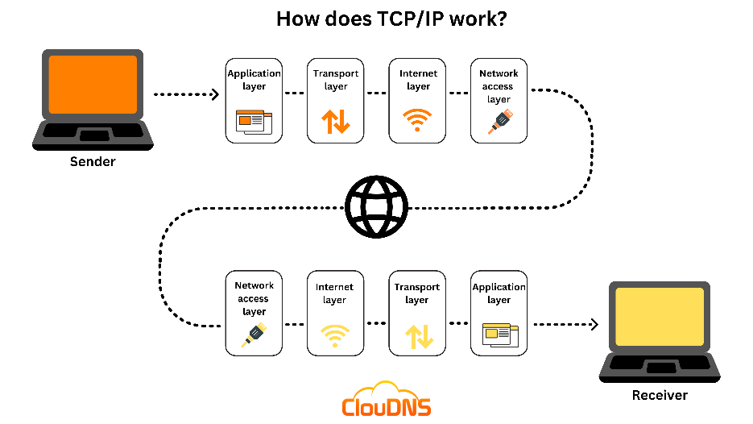

# **Layer by Layer explanation**

## **Application Layer**

The **Application Layer** is the topmost layer in the TCP/IP model and directly interfaces with user-facing software and services. It combines the responsibilities of three OSI layers: **Application, Presentation, and Session**. This layer is where network communication becomes meaningful to the end user.

It provides protocols that allow software to send and receive data across the network and handle tasks such as email, file transfer, domain name resolution, and web browsing.

* **Main Role:** Provides protocols for user-level services and applications
* **Examples of Protocols:**
  + **HTTP/HTTPS** – Web browsing
  + **SMTP/POP3** – Email communication
  + **FTP/SFTP** – File transfers
  + **DNS** – Domain name resolution
* **Real-world Example:** When you access a website through your browser, it uses **HTTP or HTTPS** to send your request to the server and receive a web page in return.
* **Internship relevance:** Application Layer protocols like HTTP, SMTP, and DNS are critical when managing cloud-hosted apps, configuring DNS records, or deploying web services.
* The Application Layer does not concern itself with how data is delivered that responsibility lies with the lower layers. Instead, it focuses on **what data is being sent** and **how it should be interpreted** by the end-user application.

“The Application Layer provides protocols that allow software to send and receive information and present meaningful data to users.” — Microsoft Learn [[1]](https://learn.microsoft.com/en-us/xandr/industry-reference/tcp-ip)

## Transport Layer

The **Transport Layer** is responsible for providing **reliable or fast data transfer** between devices across a network. It manages how data is broken into segments, ensures the correct delivery of these segments, and reassembles them at the receiving end.

This layer supports two main protocols:

* **TCP (Transmission Control Protocol):** Ensures **reliable, ordered, and error-checked** delivery of data.
* **UDP (User Datagram Protocol):** Offers **faster, connectionless communication** without delivery guarantees useful for real-time applications.
* **Main Role:** End-to-end communication between hosts, including error checking and data recovery
* **Key Protocols:** TCP and UDP
* **Functions:** Segmentation, reassembly, flow control, and error handling
* **Real-world Example:**
  + **TCP:** Used for secure file transfers (FTP), emails (SMTP), and loading web pages (HTTP/HTTPS)
  + **UDP:** Used in real-time services like video calls, online gaming, or live streaming, where speed is more important than perfection

“The Transport Layer is responsible for establishing a connection between hosts and ensuring complete data transfer.” — Microsoft Learn [[1]](https://learn.microsoft.com/en-us/xandr/industry-reference/tcp-ip)

This layer is crucial in **cloud and containerized systems** where microservices need to communicate reliably, or where performance needs dictate protocol choices (e.g., UDP for telemetry or TCP for secure APIs).

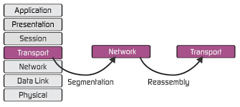

## Internet Layer

The **Internet Layer** in the TCP/IP model is responsible for **logical addressing, routing, and packet delivery** between networks. It ensures that data can move across different physical and virtual networks by assigning IP addresses and determining the best route for data to travel.

This layer is the equivalent of the **Network Layer in the OSI model**, and it handles **packet forwarding, fragmentation**, and **reassembly** during transmission across large or complex networks.

* **Main Role:** Determine the best path for data to travel from source to destination across multiple networks
* **Key Protocols:**
  + **IP (Internet Protocol):** Provides logical addressing (IPv4/IPv6)
  + **ICMP:** Used for diagnostics and error reporting (e.g., ping command)
  + **ARP (Address Resolution Protocol):** Maps IP addresses to MAC addresses
* **Functions:** Routing, addressing, packet forwarding, and fragmentation
* **Devices involved:** Routers, Layer 3 switches
* **Real-world Example:** When you send an email from one country to another, the Internet Layer ensures that packets travel through various routers and networks to reach the correct mail server

“The Internet Layer routes packets across network boundaries and provides logical addressing with IP.” — Microsoft Learn [[1]](https://learn.microsoft.com/en-us/xandr/industry-reference/tcp-ip)

In cloud networking, understanding the Internet Layer is vital for tasks like configuring **virtual networks**, **firewall rules**, and **load balancers**, where IP addresses and routing paths are centrally managed.

## Network access layer

The **Network Access Layer** (also called the **Link Layer**) is the **lowest layer** of the TCP/IP model. It is responsible for the **physical transmission of data** over the network, including both hardware-level communication and the formatting of data for transmission.

It corresponds to the **Data Link Layer and Physical Layer** of the OSI Model and handles how data is **encoded into signals**, how it is sent over cables or wireless media, and how devices on the same local network **identify and communicate** with one another.

* **Main Role:** Transmit raw data over the network hardware and manage how devices access the medium
* **Key Protocols/Technologies:** Ethernet, Wi-Fi (IEEE 802.11), ARP, MAC addressing
* **Functions:** Framing, physical addressing (MAC), error detection, media access control
* **Devices involved:** Network Interface Cards (NICs), switches, hubs, access points
* **Real-world Example:** When your computer connects to a Wi-Fi network, this layer handles signal transmission, MAC addressing, and data frame construction

“The Network Access Layer defines how data is physically sent through the network, including addressing and access control.” — Microsoft Learn [[1]](https://learn.microsoft.com/en-us/xandr/industry-reference/tcp-ip)

This layer is particularly important when working with **network interface configurations**, **subnet planning**, and **hardware-level troubleshooting** in enterprise or cloud deployments.

# **Comparison with OSI Model**

Although the **TCP/IP and OSI models** both describe network communication in layers, they differ in structure, purpose, and implementation. The OSI model was developed as a **theoretical framework** to standardize network communication, while the TCP/IP model was built as a **practical, working solution** for real-world data exchange over the internet.

The TCP/IP model has **4 layers**, whereas the OSI model has **7**. Several OSI layers are combined in TCP/IP especially in the top and bottom ends.

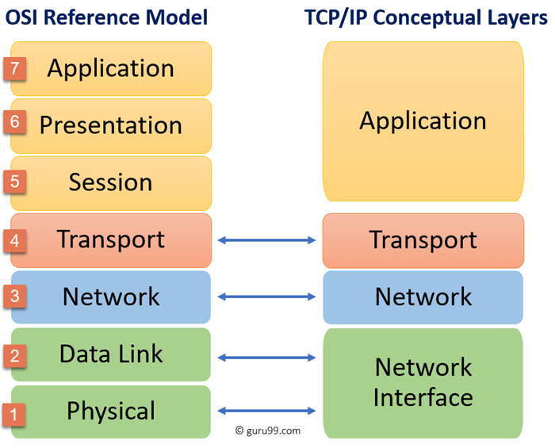

* **OSI** focuses more on **standardization and teaching**, and is used as a **reference model**
* **TCP/IP** is **protocol-based** and forms the core of all modern internet and cloud communication

“While the OSI model is conceptual, TCP/IP is the foundation of real-world networking, with built-in protocols like TCP, IP, and DNS.” — Microsoft Learn [[1]](https://learn.microsoft.com/en-us/xandr/industry-reference/tcp-ip)

In practical use such as cloud networking, DevOps, or system design **TCP/IP is implemented**, while **OSI is referenced** for understanding structure and troubleshooting.

# **Real world example Uses and Cases**

The **TCP/IP model** is not just a theoretical framework it is the **core of real-world network communication**, from local networks to the global internet. Every time a device sends or receives data whether it's a laptop, server, cloud container, or mobile phone it's using TCP/IP under the hood.

In modern IT environments, especially cloud-based infrastructure like Microsoft Azure or AWS, understanding TCP/IP is essential. System administrators, network engineers, and DevOps professionals rely on TCP/IP principles to design **secure, scalable, and efficient networks**.

**🔹 Use Cases in Real-World Environments:**

* **Cloud Infrastructure:**  
  Configuring virtual networks (VNets), IP addressing, and subnetting depends on Internet Layer concepts. Transport protocols like TCP are used in **load balancing**, **web traffic**, and **database connections**.
* **Web Applications:**  
  HTTP/HTTPS at the Application Layer allows users to interact with cloud-hosted apps. Understanding TCP/IP is crucial when deploying **front-end to back-end communications**.
* **Virtual Machines & Containers:**  
  VM-to-VM and container communication uses TCP/UDP over IP, often through defined network security groups (NSGs) or firewall rules.
* **Network Security:**  
  Protocols like ICMP are used in diagnostics (e.g., ping), while proper Transport Layer use supports **firewall configurations**, **intrusion detection systems (IDS)**, and **VPNs**.

This model remains essential for configuring infrastructure, diagnosing issues, and building secure communication across any modern system.

# **Conclusion**

The **TCP/IP model** is the backbone of digital communication in today’s networked world. From sending an email to deploying multi-tier cloud applications, this model ensures that data travels reliably and securely between devices across vast and varied networks.

Unlike the OSI model, which serves as a conceptual learning framework, TCP/IP is **practically implemented and universally adopted**. Each of its four layers plays a distinct and vital role — from defining how applications interact with the network to managing the physical delivery of data over network hardware.

For professionals in cloud infrastructure, networking, or cybersecurity, understanding the TCP/IP model is not optional — it is foundational. During this internship, tasks like configuring web servers, managing virtual networks, or setting up secure communication between application tiers directly rely on TCP/IP concepts.

As technologies evolve, TCP/IP continues to adapt and remain relevant, making it an essential model for both academic understanding and real-world application in the cloud-driven IT landscape.

# **Reference**

[[1]](https://learn.microsoft.com/en-us/xandr/industry-reference/tcp-ip) Microsoft. (2024). The OSI Model. Microsoft Learn. Retrieved from [https://learn.microsoft.com/en-us/xandr/industry-reference/tcp-iphttps://learn.microsoft.com/en-us/xandr/industry-reference/tcp-ip](https://learn.microsoft.com/en-us/xandr/industry-reference/tcp-ip)